**Project Design Phase-II**  
**Technology Stack**   
  
**Project Name:** Garage Management System

**Team ID**: LTVIP2025TMID31528  
**College Name: Ideal Institute Of Technology**

### **Technical Architecture**

The Garage Management System is built on the Salesforce platform using low-code/no-code tools with automation features to manage garage operations efficiently. Below is the architectural breakdown of components and technologies used in the system.

### **Table-1: Components & Technologies**

| **S.No** | **Component** | **Description** | **Technology** |
| --- | --- | --- | --- |
| 1 | **User Interface** | Users interact via a web-based Salesforce UI | Salesforce Lightning Pages |
| 2 | **Application Logic-1** | Handles vehicle service request and service tracking | Salesforce Flows, Apex Triggers |
| 3 | **Application Logic-2** | Handles customer data and vehicle assignment logic | Apex Classes, Validation Rules |
| 4 | **Application Logic-3** | Automation for sending reminders and generating bills | Salesforce Workflow Rules, Process Builder |
| 5 | **Database** | Stores customer, vehicle, service, and billing data | Salesforce Standard & Custom Objects |
| 6 | **Cloud Database** | All data stored in Salesforce cloud database | Salesforce Platform Database |
| 7 | **File Storage** | Stores invoice documents and service records | Salesforce Files, Attachments |
| 8 | **External API-1** | To send SMS notifications to customers | Through Gmail |
| 9 | **External API-2** | Optional integration for validating vehicle number | Vehicle Info API |
| 10 | **Machine Learning Model** | Not applicable currently | N/A |
| 11 | **Infrastructure (Cloud)** | Application is hosted entirely on Salesforce cloud infrastructure | Salesforce Cloud |

### **Table-2: Application Characteristics**

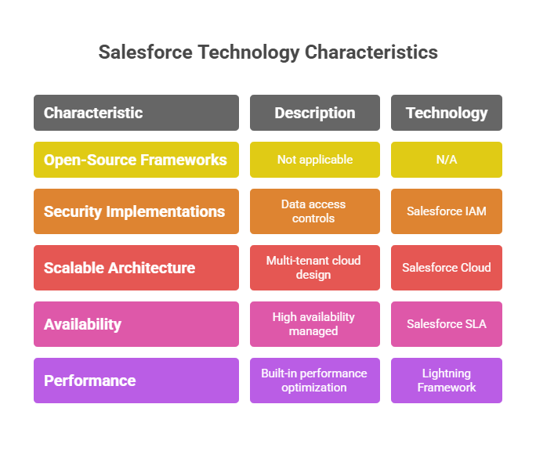

**References:**  
- https://c4model.com/  
- https://www.ibm.com/cloud/architecture  
- https://aws.amazon.com/architecture  
- https://developer.salesforce.com/  
- https://medium.com/the-internal-startup/how-to-draw-useful-technical-architecture-diagrams-2d20c9fda90d